IDEALENS VR SDK（Unity）

Development Guide
Date | Author | Version
2019.02.20 | Dean | 0.1.0
2019.02.28 | Dean | 0.2.0
2019.03.22 | Dean | 0.2.2
2019.05.16 | Dean | 1.0.0
2019.08.05 | Dean | 1.1.0

Contents
1 Overview of the SDK 5
1.1 Platform Support 5
1.2 Development Environment 5
2 SDK Integration 5
2.1 Import IVRSDK 5
2.2 Add Components 6
2.3 Quality Settings 6
2.4 Project Settings 6
2.5 Build And Run 7
3 Components Introduction 8
3.1 VR Camera Component 8
3.1 Interaction Component 9
3.2 Gaze Component 10
1.4 Hand Controller Component 11
3.5 IVRGraphicRaycaster 11
4 Input 12
4.1 Delegate (Call IVRTouchpad) 12
4.2 Get (Call IVRInput) 12
5 Development Note 15
5.1 Github 15
5.2 Splash LOGO 15
5.3 Android Theme (Optional) 15
5.4 About Camera 15
5.5 UGUI Setting 16
5.5 Antialiasing Setting 16
6 API 17

1 Overview of the SDK

1.1 Platform Support
Device ：IDEALENS K4

1.2 Development Environment
Unity： Unity 5.6.6f2 – Unity 2018.2.16f1
Android： 8.0 and above
Java： 1.7 and above

SDK Integration

2.1 Import IVRSDK
Import IVRSDK_V.x.x.x.unitypackage file in your Unity3D project.
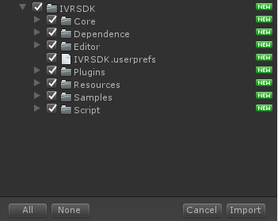
OR,

Git clone code from the URL:
https:
https://github.com/IDEALENSGroup/IVRSDK_Unity.git
ssh:
git@github.com:IDEALENSGroup/IVRSDK_Unity.git

2.2 Add Components
Add IVRManager and IVRInputModuleManager prefabs in Hierarchy (prefabs are under the /IVRSDK/Resource/Prefabs)
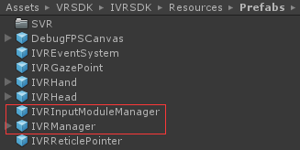
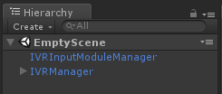
Notice: If exists other cameras in hierarchy, please delete it.

Quality Settings
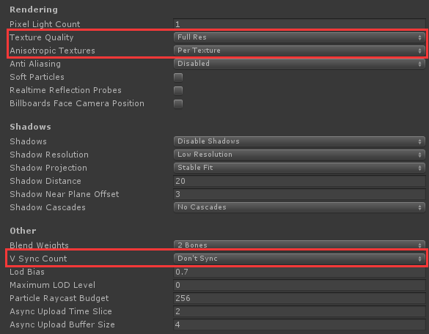

2.4 Project Settings
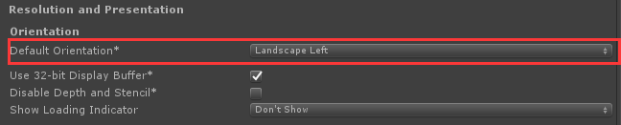
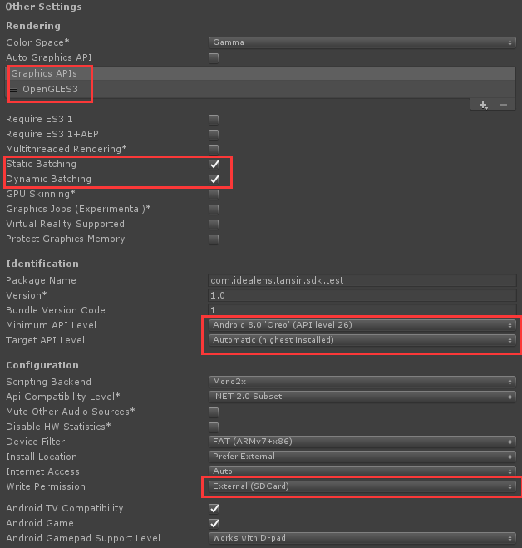

2.5 Build And Run
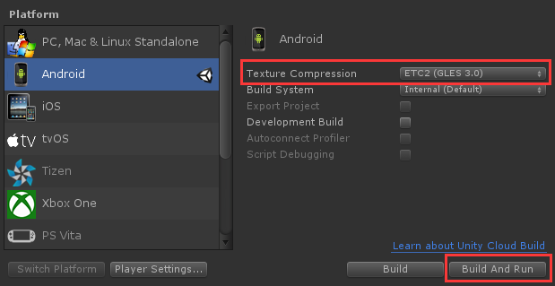

3 Components Introduction

3.1 VR Camera Component

Component Prefab:
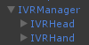
IVRHead: VR Head，For rendering
IVRHand: VR Hand，For hand controller，just support H1000 and Ximmerse.

Component Script:
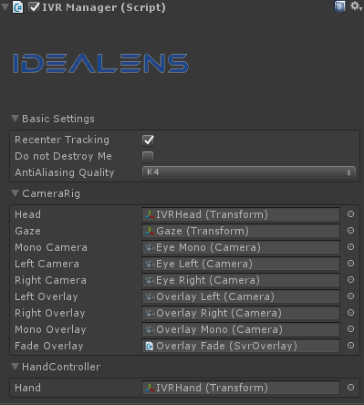

Option | Description | Comment
Recenter Tacking  （Checked<default>)） | If checked，after long pressing touchpad for 3s，application recenter tracking.
Do not Destroy Me  （Unchecked<default>） | If checked, this component will not be destroyed.
AntiAliasing Quality  (K4<default>) | Antialiasing quality level | K0:No AntiAliasing；K1,K2,K4: Three different antialiasing quality
Head | Head Node | Reference object: IVRHand
Gaze | Anchor Node | Reference object: Gaze
Left Camera | Render Camera(Left Eye) | Reference object: Eye Left
Right Camera | Render Camera(Right Eye) | Reference object: Eye Right
Left Overlay | Overlay Camera(Left Eye) | Reference object: Overlay Left
Right Overlay | Overlay Camera(Right Eye) | Reference object: Overlay Right
Hand | Hand Node | Reference object: IVRH instead and

Notice: Overlay Camera just used as rendering anchor object, not rendering UI element and models.

Interaction Component
Component Prefab:

Component Script:
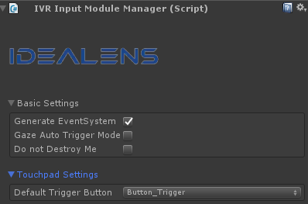
This component will generate customized Input Module that manage global input events.

Option | Description | Comment
Gernerate EventSystem  （Checked<Default>） | If checkbox is checked, EventSystem component will be generated automatically and be set as child node of IVRInputModuleManager. And EventSystem will be taken over by IVRInputModule.
Gaze Auto Trigger Mode  （Unchecked<Default>） | If checkbox is checked,“Gaze Auto Trigger Mode”will be enabled. Just gaze the object until the progress is done, the event will be triggered. But the object must implement IPointerClickHandler interface. | This is a delta feature. Not recommend to use.
Do not Destroy Me  （Unchecked<Default>） | If checkbox is checked, this component will not be destroyed.
Default Trigger Button  (Button_Trigger<Default>) | Set default button that can interact with UGUI when the hand controller is connected. | Button_Trigger: press down trigger  Button_TP: press down touchpad  Button_Trigger_And_TP:both trigger and touchpad

Gaze Component
Component: IVRGazePoint
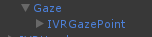

Component Script:
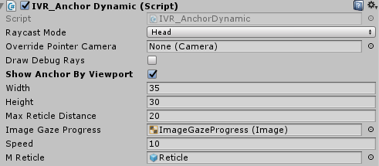
The script is used to control Anchor object
Option | Description | Comment
Raycast Mode  (Head) | Raycast Mode
Speed | Moving speed of anchor on the Z-axis
Show Anchor By Viewport | Show anchor by Viewport | If enabled, you can set it’s viewport to show.
Width/Height | Width and height of viewport | When the anchor is out of the viewport, it will disappear.
ImageGazeProgress | Use Image component to show the progress when gazing. | If you want enable this feature，need to enable “Gaze Auto Trigger Mode”in IVRInputModuleManager.

Hand Controller Component
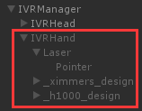
When hand controller is connected, IVRHand will be active. Hand controller model will display on your right side.
Please pair hand controller in Launcher at first.

3.5 IVRGraphicRaycaster
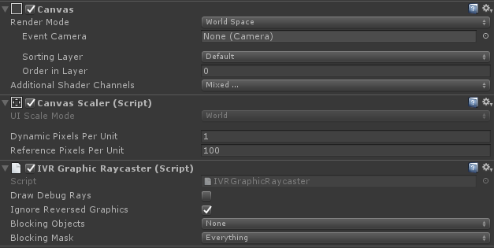
IVRGraphicRaycaster is used for interacting with UGUI system, must be attached to Canvas, only support “World Space” mode.

Input
Manager input event for head touchpad and hand controller.
There are two ways to get input event.

4.1 Delegate (Call IVRTouchpad)

Touch Event | Description | Comment
TouchEvent_OnSingleTap | Single Tap
TouchEvent_OnDoubleTap | Double Tap
TouchEvent_OnSwipe | Swip(Need press up) | return<Swip Direction>
TouchEvent_OnSwipDirect | Swip(No need press up) | return<Swip Direction>
TouchEvent_OnLongPress | Long Press
TouchEvent_OnPressDown | Press Down
TouchEvent_OnPressUp | Press Up
TouchEvent_OnScroll | Scroll | return<Touch position and touch step>
ButtonEvent_OnBackPress | Back Key
ButtonEvent_OnAppPress | App Key
Please refer to the example：IVRSample_Touchpad

4.2 Get (Call IVRInput)
(Get，GetDown，GetUp ) can be used for checking user input, the type of return value is boolean. Please call them in Update, like this:
if (IVRInput.GetDown(IVRInput.Button.One))
{
//The Button One
}
if (IVRInput.Get(IVRInput.Button.One))
{
//The Button One
}
if (IVRInput.GetUp(IVRInput.Button.One))
{
//The Button One
}
Get，GetDown，GetUp need pass event type and controller type. Event Type：Button，RawButton，Axis1D，RawAxis1D，Axis2D，RawAxis2D，Touch，RawTouch. Controller type : Controller.

Button Type：
Event Type | Hand Controller mapping | Head Touchpad mapping | BT controller mapping
One | Touchpad press |  | A Key
Two | App Key |  | B Key
Three |  |  | X Key
Four |  |  | Y Key
Start |  | Touchpad tap | Start Key
Back | Home Key | Back Key | Back Key
PrimaryShoulder |  |  | Left Shoulder Key
PrimaryIndexTrigger | Trigger Key |  | Left Trigger Key
PrimaryThumbstick |  |  | Left Thumbstick
PrimaryThumbstickUp |  |  | Left Thumbstick Up
PrimaryThumbstickDown |  |  | Left Thumbstick Down
PrimaryThumbstickLeft |  |  | Left Thumbstick Left
PrimaryThumbstickRight |  |  | Left Thumbstick Right
PrimaryTouchpad | Touchpad tap | Touchpad tap
DpadUp | Swip Up | Swip Up | Left Thumbstick Up
DpadDown | Swip Down | Swip Down | Left Thumbstick Down
DpadLeft | Swip Left | Swip Left | Left Thumbstick Left
DpadRight | Swip Right | Swip Right | Left Thumbstick Right
Up | Swip Up | Swip Up | Left Thumbstick Up
Down | Swip Down | Swip Down | Left Thumbstick Down
Left | Swip Left | Swip Left | Left Thumbstick Left
Right | Swip Right | Swip Right | Left Thumbstick Right

Axis1D Type：
Event Type | Hand Controller mapping | Head Touchpad mapping | BT controller mapping
PrimaryIndexTrigger | Trigger Key |  | Left Trigger Key

Axis2D Type：
Event Type | Hand Controller mapping | Head Touchpad mapping | BT controller mapping
PrimaryTouchpad | Touchpad | Touchpad
PrimaryThumbstick |  |  | Left Thumbstick

Touch Type：
Event Type | Hand Controller mapping | Head Touchpad mapping | BT controller mapping
PrimaryTouchpad | Touchpad | Touchpad

Controller Type：
Touchpad | Head Touchpad Input Device
Remote | Hand Controller Input Device
Gamepad | Common BT Gamepad Input Device
Active | Active Device Currently
All | Any Device

For Get，GetDown and GetUp , the default value of controller type is Active. Or you can change controller type like this:

if (IVRInput.GetDown(IVRInput.Button.One,IVRInput.Controller.Gamepad))
{
//The Button One
}

This case only show receive input event from BT gamepad, not receive event from hand controller touchpad. If you want to know how to use IVRInput, recommend you run and check IVRSample_Input in IVRSDK.

Development Note

5.1 Github
Recommand use Git to update IVRSDK
https:
https://github.com/IDEALENSGroup/IVRSDK_Unity.git
ssh:
git@github.com:IDEALENSGroup/IVRSDK_Unity.git

5.2 Splash LOGO
Recommend use black texture as splash image：
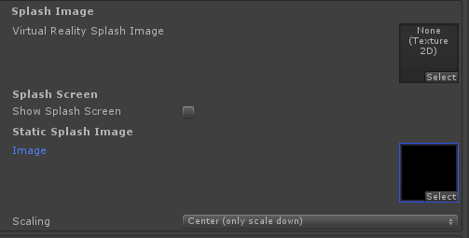

5.3 Android Theme (Optional)
If app started and flashing white screen, to solve this you can find
Unity\Editor\Data\PlaybackEngines\AndroidPlayer\Apk\res\values\styles.xml，and change android:Theme.Light.NoTitleBar.Fullscreen to android:Theme.Black.NoTitleBar.Fullscreen.

About Camera
Do not add other Camera component as Main Camera.

5.5 UGUI Setting
Please set Render Mode of Canvas as “World Space”.

Antialiasing Setting
Fllow Qualcomm SDK document: In Unity3D quality setting, set【Anti-Aliasing = Disabled】,and set quality in IVRManager component. The default setting is K4, means the best quality. K0 means no antialiasing，K1,K2,K4 means three different antialiasing quality level.
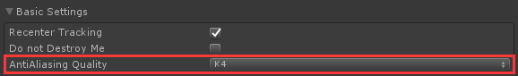

API
Provide by IVRPlugin.

Method | Function | Parameter
IVR_ResetPose | Reset View | none
ShowToast | Show android system toast | message: your message  time: message display duration，default set 3000ms
ShowDialog | Show android system dialog | tilte: title text  message: content text  positiveButtonLabel : button label text，default set“OK”  actionOk: button event
GetDeviceResolutionType | Get screen type  (DeviceResolutionType ：Display_Unknown，Display_2K，Display_4K) | none
OpenCinema | Call Cinema video player | path: video absolute path
OpenImageViewer | Call ImageViewer | path: image absolute path

Thanks for your support！

